Netflix Movie and TV Show Clustering
Manas N Mukherjee
Cohort, Boston

Abstract

Netflix is a subscription service model that offers personalized recommendations, to help viewers find shows and movies of interest. The streaming giant uses the content details and app usage data to make recommendations to each user.
In order to build recommendation engines, grouping and analyzing the content catalogue may prove to be extremely beneficial. This would aid in planning the type of content needed to be signed to effectively suit the entertainment needs of different client bases.
After we take all the under consideration, it’s astoundingly troublesome to generalize a movie and say that everybody would love it. However, with all that said, it’s still seen that similar movies are liked by a selected part of the society.
In this project different clustering techniques namely, K-Means Clustering, affinity propagation Clustering are implemented and analyzed to efficiently cluster Netflix video content data.

Key Words: Machine learning; k-means clustering algorithm; affinity propagation.

Problem Statement
In this project we’ll be using the Netflix Content Data to:
  - Understand distributions of different types of content categories across Netflix,
  - Understand the type of content available in different countries,
  - Find if Netflix has been focusing increasingly on TV shows as compared to movies, and
  - Cluster similar content based on text-based features.

Introduction

Netflix was founded in 1997 by Marc Randolph and Reed Hastings. In its early days the
company positioned itself in the DVD-rental business with an innovative twist which has changed the world of entertainment. While technology companies are often associated with open platform organization, it's been proved that how Netflix is more similar to a closed portal creating and curating content, with data and technology at its core. The recommender system and the personalization techniques in place at Netflix have allowed the company to gain more power and become a more solitary player with less connections to the entertainment eco-system. Data have influenced the creation of tv shows and movies that are distributed on its online platform, making technology and entertainment intertwined while reinforcing the strength of the portal. The experience of Netflix is contributing to the changes in the viewing experience, becoming an increasingly focused data-harvesting practice.

Netflix has legitimized a behavior that was being the new norm in the world of media consumption. Traditional television, with few channels and a limited offer, could not contain the need for a tailored offer and unlimited fruition of content. Through illegal websites, the streaming of content was already available on the Internet, causing incredible losses for the traditional media world. Netflix has been able to institutionalize online streaming, with a platform that allowed those new forms of media consumption that had been developing naturally over the years.

The recommender system deals with an outsized volume data present by filtering the foremost necessary information supported by the information provided by a user’s preference and interest. It finds out the match between user and item and imputes the similarities between users and ratings for recommendation. Both the users and the services provided have benefited from these sorts of systems, the standard and decision-making method has additionally improved through these sorts of systems.

select content based on each user's unique profile. The engine filters over 3,000 titles at once utilising 1,300 recommendation clusters based on user choices. The engine’s precise recommendations account for 80% of the Netflix viewer activity. According to estimates, Netflix saves over $1 billion annually thanks to the NRE.
This project aims to cluster the video content available on Netflix based on the company’s site data. Apart from aiding in the development of an efficient recommendation system, clustering the video content would also provide information about the type of content the company is interested in listing on its site. Thus giving an insight to content creators and filmmakers on the type of video content in demand.
In 2018, Flixable, a third-party Netflix search engine, released a report showing the number of TV shows on Netflix tripling since 2010. Apart from clustering the video content, a comprehensive exploratory data analysis will be performed during this project to understand the trends in the diverse video content catalogue and to verify the findings of Flexible, that Netflix has been focusing on producing TV shows in recent years.

Data Description

  - Data Preparation

The Netflix Content dataset contains data of 7,787 video content listed on the platform collected from Flixable, a third-party Netflix search engine. This dataset consists of 12 attributes, providing content details about the video cast, director and duration corresponded with the site details like signing date, countries the content was produced in and topics the content was being listed under. The provided features are displayed in Table. 1.

Feature | Type | Samples
show_id | Continuous | s1,s2,s3...
title | Text | [3%, Ozark,...]
type | Categorical | Movie/ TV Show
rating | Categorical | TV-MA, TV-R, R,  PG-13....
director | Text | Raúl Campos, Jan Suter
cast | Text | David Attenborough
country | Categorical | United States
date added | Categorical | August 14, 2020
release year | Numerical | 1999,2000,2001..
duration | Categorical | 1 season, 2 seasons… /  90 mins, 120 mins...
listed_in | Text | [International Movies, Drama..]
description | Text | In a future where the elite inhabit a..

  - Exploratory Data Analysis

Exploratory Data Analysis (EDA) is the most commonly used methodology to summarize and visually analyze data using different parameters.
The Pandas package has been utilized in data handling while Matplotlib, Seaborn, and Wordcloud libraries have been used for data visualization.
For the preliminary analysis, the timelines of Netflix movies and TV shows were analyzed. The histogram plot of the number of TV shows and Movies premiered and signed on each year is displayed in Fig. 1 and Fig. 2. From Fig. 1, we can observe that most movies streaming on the platform were released
after 2010 while a large portion of the TV Shows streaming on the platform was released after 2015. The year 2017 had the highest number of movie and TV show releases on the platform.
From Fig. 2, we can observe that Netflix of the number of movies and TV shows added by Netflix each month.
Fig. 3 and Fig. 4 show the Pie distribution of the type and the rating of the video content streaming on Netflix. From these plots, we can observe that there are almost twice as many movies as TV shows on Netflix and that the majority of the content is rated for Mature Audiences and for audiences over 14 years old.
Fig. 5 and Fig. 6 show the histogram plot of the duration of movies and TV show seasons on Netflix. These histogram plots show that the movies on Netflix have an average duration ranging from 90 to 110 minutes while the TV shows on Netflix have a span of only one season.
Fig. 7 shows the different genres available on Netflix. It is observed that the top video content genres on Netflix are Drama, Comedy, Documentary, Action and Adventure and Romance.
Fig. 8 shows the top video content-producing countries on Netflix. The top five biggest video content producers are the United States of America, India, the United Kingdom, Canada and France.
The insights from Fig. 7 and 8 were combined to understand the type of content produced in different countries.

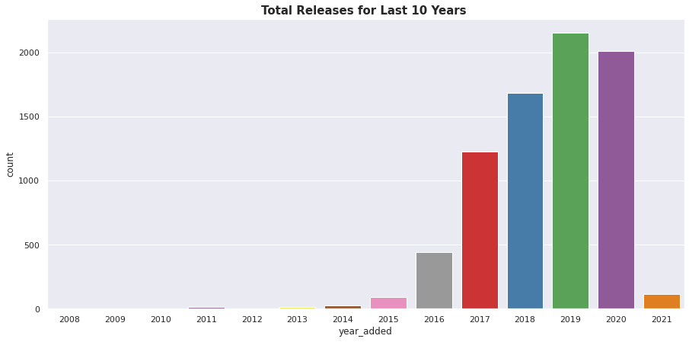

Figure 1 : Number of Movies & Shows released by last 10 Year

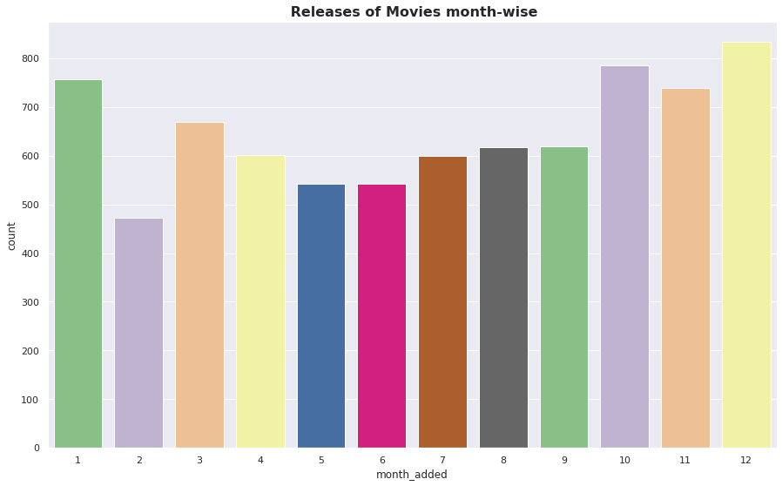

Figure 2 : Number of Movies & Shows released by each month

Fig. 1 shows the bar plot of the number of movies and TV shows released each year Fig. 2 shows the bar plot of the number of movies and TV shows added by Netflix each month
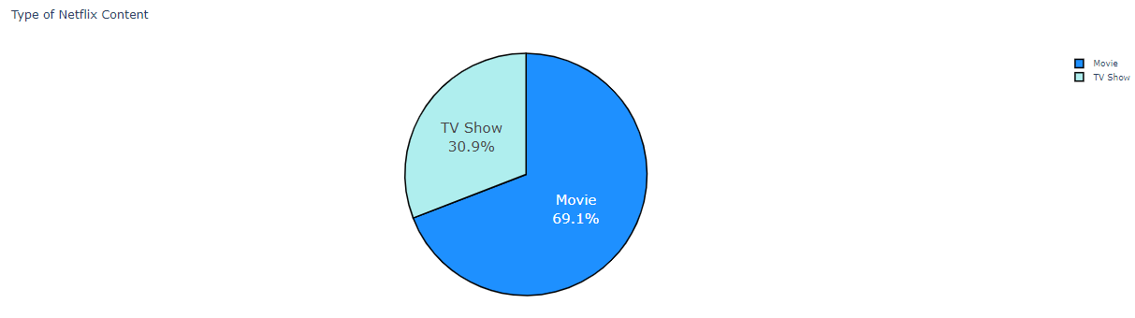
Figure 3 : Types of Video Content on Netflix

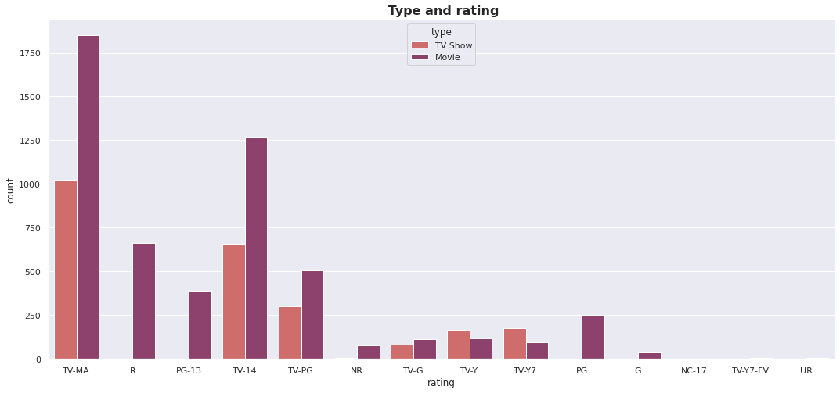
Figure 4 : Video Content Rating on Netflix

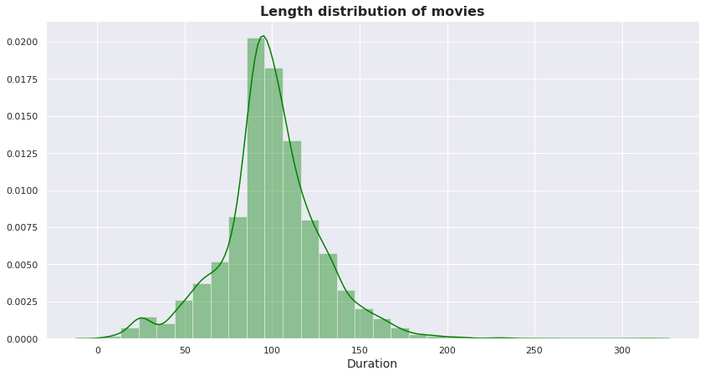
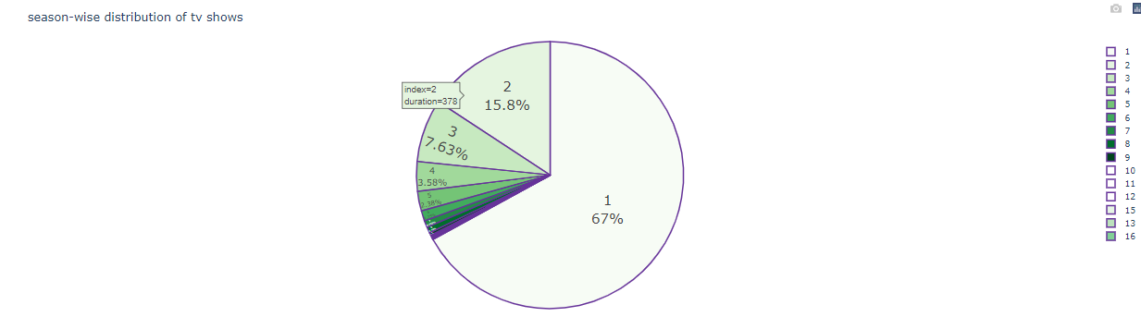
Figure 5 : Histogram Plot of Movie Duration Figure 6 : Histogram Plot of TV Show Season

Fig. 3 depicts the pie plot of video content type on Netflix. Fig. 4 depicts the bar plot of video content ratings on Netflix. Fig. 5 shows the histogram plot of the duration of movies available on Netflix. Fig. 6 shows the histogram plot of TV show seasons on Netflix.

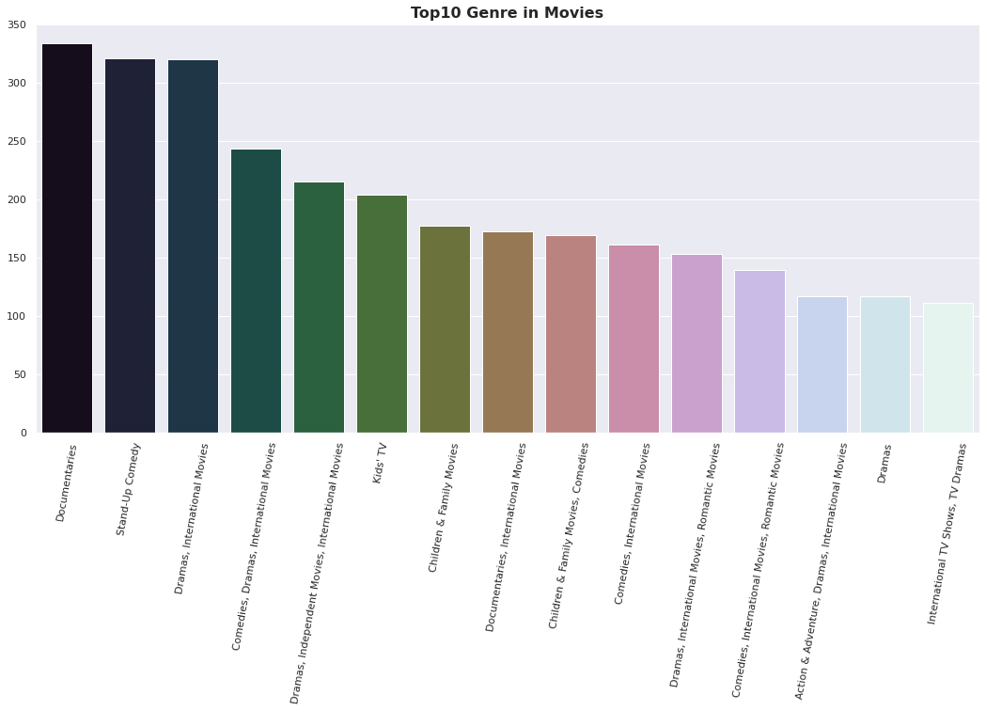
Figure 7 : Video Content genres available on Netflix

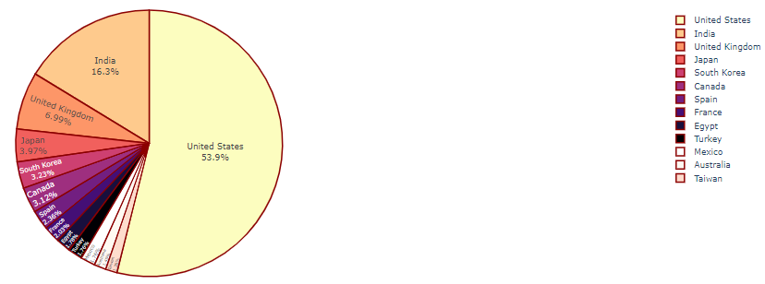

Figure 8 : Top Netflix Video Content Producing Countries

  - Feature Engineering

Null values were observed in ‘director’, ‘cast’, ‘rating’ and ‘country’. As these values were text-based, the null values were replaced with the label ‘unknown’. Attribute ‘released year’ was converted from string to date-time type. The year of release was extracted from this feature and was binned by the decade to perform effective clustering. The attribute ‘ratings’ contained age-based ratings of movies and TV shows. These movie and TV show ratings were merged based on age using the maturity rating guidelines provided by Netflix and Amazon.
The attribute ‘listed_in’ provided genres for TV shows and movies separately. The common genres from both content types were combined and the non-genres like ‘International Movie’ and ‘Independent Film’ were removed. Non-plot-related text attributes like director name, lead cast and country of production were merged with the genres they were listed under into a single text as a new attribute as ‘Movie Deets’.

  - Text Pre-processing

To handle text data, the text needs to be converted into a machine-interpretable form called a text vector. To facilitate the conversion into text vector, the text attributes are required to be cleaned to be converted efficiently. The steps involved in cleaning are
    - Tokenization: Involves breaking of natural language text into chunks of information that can be considered as discrete elements. The token occurrences in a document can be used directly as a vector representing that document.
    - Punctuation Removal: All the punctuations from the text are removed. Popularly removed punctuations are mentioned in blue ( !”#$%&'()*+,-./:;?@[\]^_`{|}~ ).
    - Stop word Removal: Common words that add very little or no significant insight to the text being processed are removed beforehand. This reduces time and computational complexity.

    - Stemming Words: Stemming is the process of reducing inflected words to their word stem, base or root form—generally a written word form. This reduces different forms of the same word carrying the same base meaning. It should be noted that stemming does not remove synonyms.The aforementioned pre-processing steps are implemented on the ‘description’ attribute and the previously derived ‘Movie Deets’ attribute.

3.4. Feature Selection

To cluster movies and TV shows on Netflix, relevant non-text attributes describing the content’s maturity ratings, duration, year of release and type of content are taken. The attributes exempted are ‘show id’, ‘title’ and ‘added date’ as the name, ID and year of the signing of the video content add little to no substance in the qualitative and quantitative characterization of the video itself.
To feed in information about the video content’s plot, directors, cast and genres, we will be using the pre-processed version of text attributes ‘description’ and ‘Movie Deets’. Vectorising the pre-processed attributes contributes a total of 2318 dimensions. For computational ease, these dimensions will have to be reduced using PCA. Upon plotting the cumulative explained variance chart (Fig. 11), it was found that 700 components were required to explain 75 per cent of the variance. This is not a fair compromise as it is still computationally taxing with a 25 per cent loss in information.
Alternatively, it was decided that the two attributes could be used to model video content into topics using Latent Dirichlet Allocation. This would make sure that all the topical information about video content is captured without putting any available information to waste. Apart from this, it also entertains the possibility of a video exhibiting multiple themes at different extents by expressing the probability a document belongs to a given topic.

Topic Modelling

Latent Dirichlet Allocation

LDA is a generative probabilistic model for collections of discrete data such as text corpora. It is a three-level hierarchical Bayesian model, in which each item of a collection is modelled as a finite mixture over an underlying set of topics. Each topic is, in turn, modelled as an infinite mixture over an underlying set of topic probabilities. In the context of text modelling, the topic probabilities provide an explicit representation of a document.

Methodology

- Affinity Propagation
- Agglomerative Clustering
- K-means Clustering
- Silhouette Coefficient or silhouette
score(meaning)
    - Affinity Propagation:

Affinity propagation (AP) is a graph-based clustering algorithm similar to k Means or K medoids, which does not require the estimation of the number of clusters before running the algorithm. Affinity propagation finds “exemplars” i.e. members of the input set that are representative of clusters.
We used Euclidean distance as an affinity estimator. After that, number of clusters we got here:
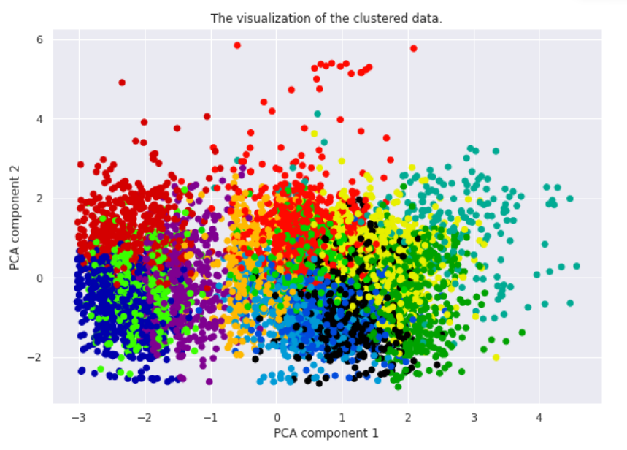
Figure1. Visualization of Custer and Silhouette Coefficient.

    - Agglomerative Clustering

The agglomerative clustering is the most common type of hierarchical clustering used to group objects in clusters based on their similarity. ... Next, pairs of clusters are successively merged until all clusters have been merged into one big cluster containing all objects.

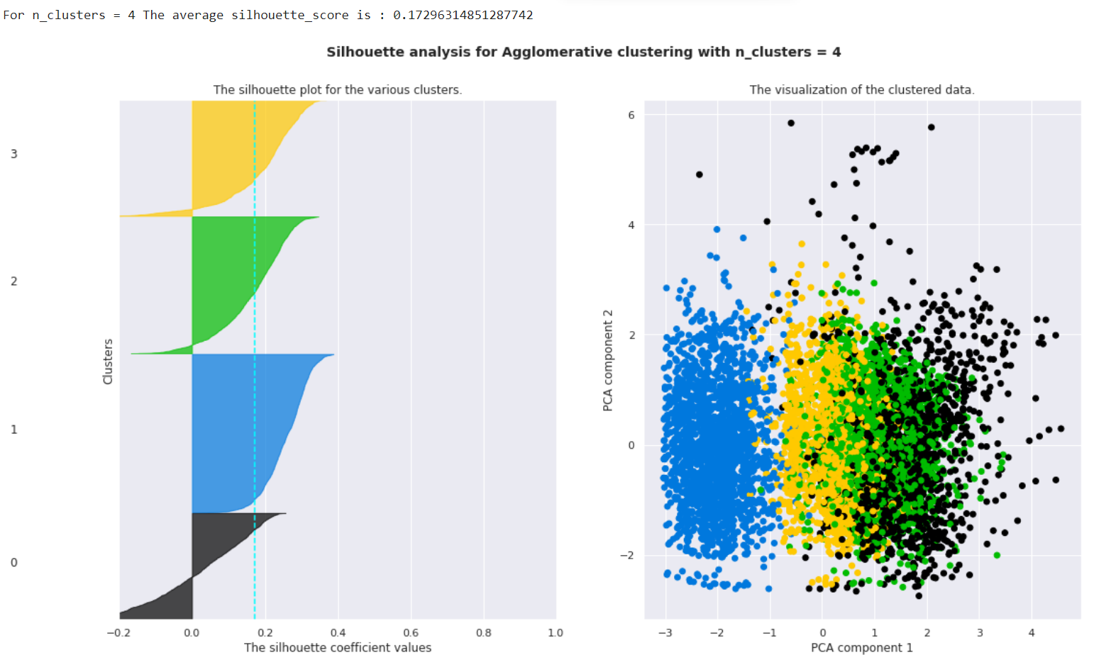
Figure2. Silhouette score and visualization
    - K-means Clustering

K-means clustering is one of the simplest and popular unsupervised machine learning algorithms. Typically, unsupervised algorithms make inferences from datasets using only input vectors without referring to known, or labelled, outcomes.
K-means algorithm works:
To process the learning data, the K-means algorithm in data mining starts with a first group of randomly selected centroids, which are used as the beginning points for every cluster, and then
performs iterative (repetitive) calculations to optimize the positions of the centroids. It halts creating and optimizing clusters when either:
• The centroids have stabilized — there is no change in their values because the clustering has been successful.
• The defined number of iterations has been achieved.
K-means algorithm is an iterative algorithm that tries to partition the dataset into K pre-defined distinct non overlapping subgroups where each data point belongs to only one group.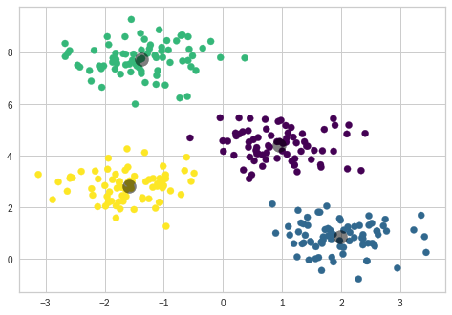 Figure3. Ideal clustering

k-means clustering is a method of vector quantization, originally from signal processing, that aims to partition n observations into k clusters in which each observation belongs to the cluster with the nearest mean (cluster centers or cluster centroid), serving as a prototype of the cluster.
We created the sample data using build blobs and used range n_clusters to
specify the number of clusters we wanted to utilize in k means.
Silhouette score and visualization
For clusters = 2 The average silhouette score is : 0.7049787496083262
For clusters = 3 The average silhouette score is : 0.5882004012129721
For clusters = 4 The average silhouette score is : 0.6505186632729437
For clusters = 5 The average silhouette score is : 0.56376469026194
For clusters = 6 The average silhouette score is : 0.4504666294372765

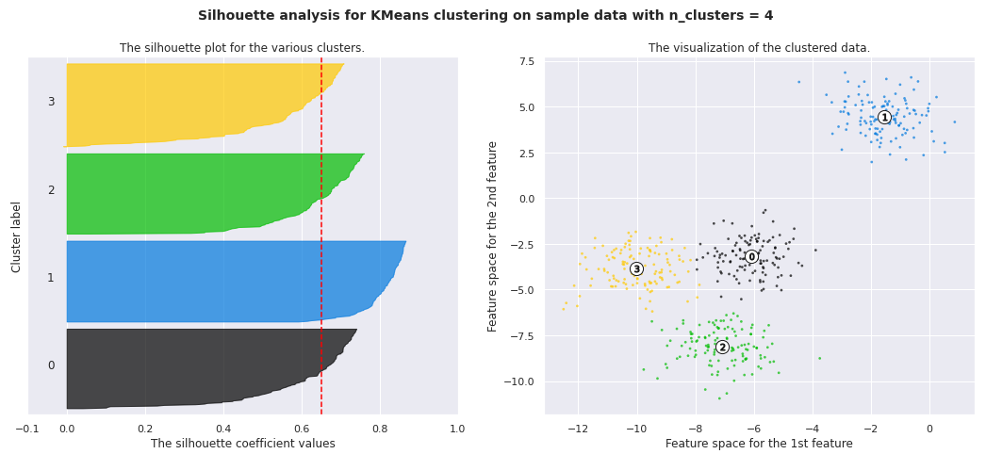
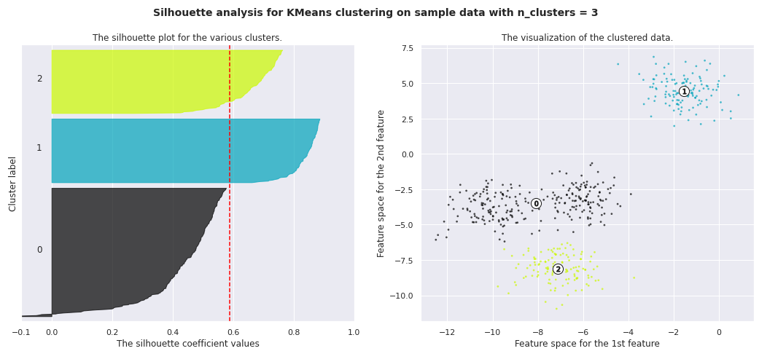
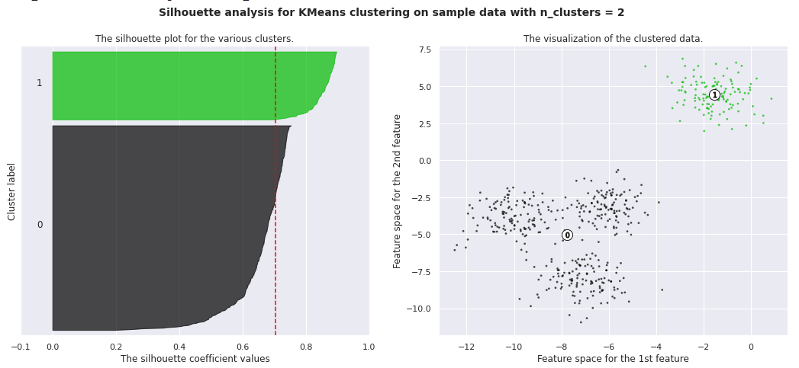

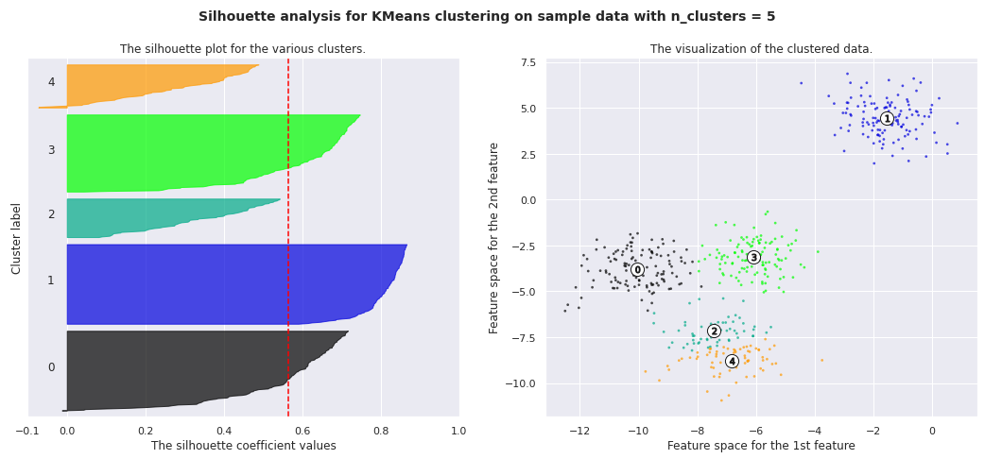

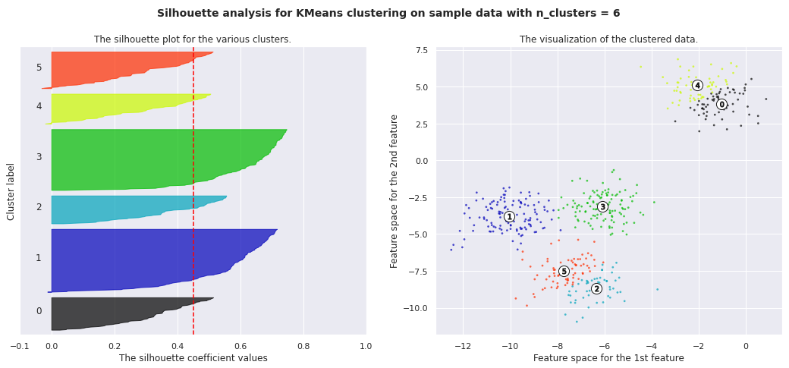

    - Silhouette Coefficient or silhouette score(meaning)

Silhouette Coefficient or silhouette score is a metric used to calculate the goodness of a clustering technique. Its value ranges from -1 to 1. 1: Means clusters are well apart from each other and clearly distinguished. ... a= average intra-cluster distance i.e., the average distance between each point within a cluster.

4.1. Silhouette’s Coefficient:
If the ground truth labels are not known, the evaluation must be performed utilizing the model itself. The Silhouette Coefficient is an example of such an evaluation, where a more increased Silhouette Coefficient score correlates to a model with better-defined clusters. The Silhouette Coefficient is determined for each sample and comprised of two scores
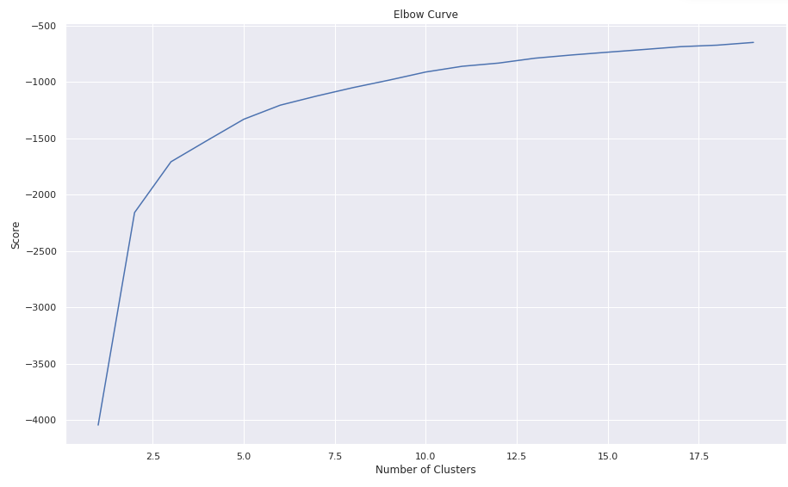
- Mean distance between the observation and all other data points in the same cluster. This distance can also be called a mean intra-cluster distance. The mean distance is denoted by a.
- Mean distance between the observation and all other data points of the next nearest cluster. This distance can also be called a mean nearest-cluster distance. The mean distance is denoted by b.

The Silhouette Coefficient s for a single sample is then given as:
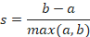

Silhouette score is used to evaluate the quality of clusters created using clustering algorithms such as K-Means in terms of how well samples are clustered with other samples that are similar to each other. The Silhouette score is calculated for each sample of different clusters. To calculate the Silhouette score for each observation/data point, the following distances need to be found out for each observation belonging to all the clusters:

4.2. Elbow Curve:

The Elbow Curve is one of the most popular methods to determine this optimal value of k.

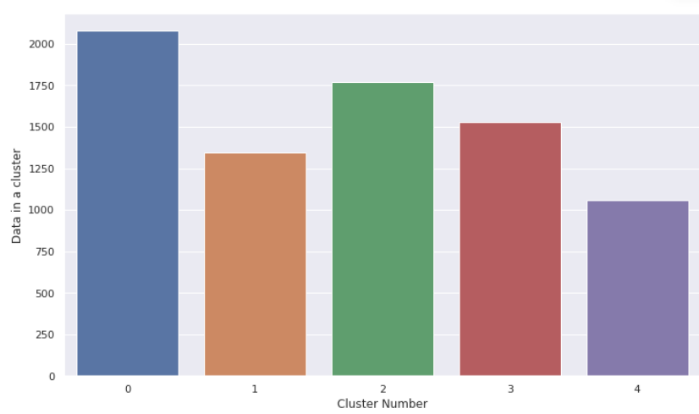
The elbow curve uses the sum of squared distance (SSE) to choose an ideal value of k based on the distance between the data points and their assigned clusters.

Challenges

1. The connection between segmentation basis and the resulting cluster is an interesting area that can be explored more. For example, it would be interesting if complete demographic data for the users in the explored data set was available, so that so that comparing the behavioural variables to the demographics variables would be viable. The current research is focused on improving the clustering algorithms for market segmentation and not on the important task of obtaining new insights of how to create a good segmentation basis.

2. Evaluating clusters is generally hard and often involves a subjective perspective. Quantitative measures (like within cluster variance) do not always guarantee that a given clustering is suitable for the company or interpretable in the eyes of a domain expert. In this case, the clustering was evaluated within a framework of a set of usefulness criteria. A potential improvement in the evaluation process would be if the company actually relied on the clustering to see if it could be used to successfully improve any company goals.

3. In this research the profitability was not considered when analyzing the customers. Often the reason for a market segmentation is simply finding and understanding the most important customers. Having data on churn-rates and lifetime value for the customers could have improved the analysis greatly. The stability criterion could have been more thoroughly investigated by dividing the data in shorter time periods and study the changes in the natural groupings. This could have helped in evaluating if there were any stable segments or segments that disappeared/formed over time.

The evaluation criteria for the understandability and homogeneity were somewhat overlapping in the sense that when users assigned to a cluster watch similar videos it indicates both homogeneity and understandability. The actionability criterion had the weakness of being difficult to quantify in a more intuitive way. Finding criteria that are uncorrelated and have a clear quantifiable metric could potentially improve similar studies. In the early phase of the project, more time should have been spent on studying previous work rather than exploring data and trying out different models. Learning more from previous research on the current state-of-the-art would have helped in avoiding unnecessary sidetracks and redundant work. For example, much time was spent on working with criteria of a good segmentation after which previous work in that exact topic was found that was later used. Another learned lesson is that tests and evaluation should be written before models are built. This helps in both in the testing to be efficient and in order to keep the analysis objective.

Conclusion

Organizations and technology in the past few years have become increasingly intertwined, arriving to the point that there is no organization without data. Data has become a carrier of value that shapes the very creation of companies and it influence the path this companies decide to take. The media world and media companies are no exception. The recommender system is an important tool of this media/data hybrid that has replaced national television and the traditional networks. The recommender is the ultimate tool that shapes contemporary society. Some see it as a facilitator while others think is more like a cage that does not allow us to see the world differently. In the case of Netflix, the algorithms create a version of the portal that suits our needs but in doing so it inevitably creates a mathematization of taste. Shows and movies whose existence is based on the data gathered by Netflix have come to dominate the streaming world in terms of views and popularity.
To conclude, we have constructed a relatively accurate data analysis to determine the genre of a given TVshow and movie. Processing and narrowing down the features of the Netfix dataset by identifying the top ten countries with top genres the audience watch and feeding this data to figure out the trend over the years, we were able to identify which actors/actresses by which directors were popular in each country. Steps such as expanding the dataset and feature set and using logistic regression might have the potential to improve upon on results in the future.

Dash Web App
I have created a Dash web app that utilizes my model to provide film recommendations based on a user's favourite movie or TV show.
